Historic Building CPD Day
25 October 2019, Bannnigham Crown and Blickling Estate

Thank you for booking a place at the above event – the details are as follows:

Start time: Registration from 0900 with coffee and refreshments
Start time 0930
Finish: 1700

Lunch is included – please advise any dietary requirements

Please head to the bar where you will be directed

Morning venue and directions
Banningham Crown, Colby Road, Banningham, Norwich, Norfolk, NR11 7DY

Parking
There is free parking at the venue
After lunch we will make our way over to Blicking which is approx 3 miles and 8 mins drive

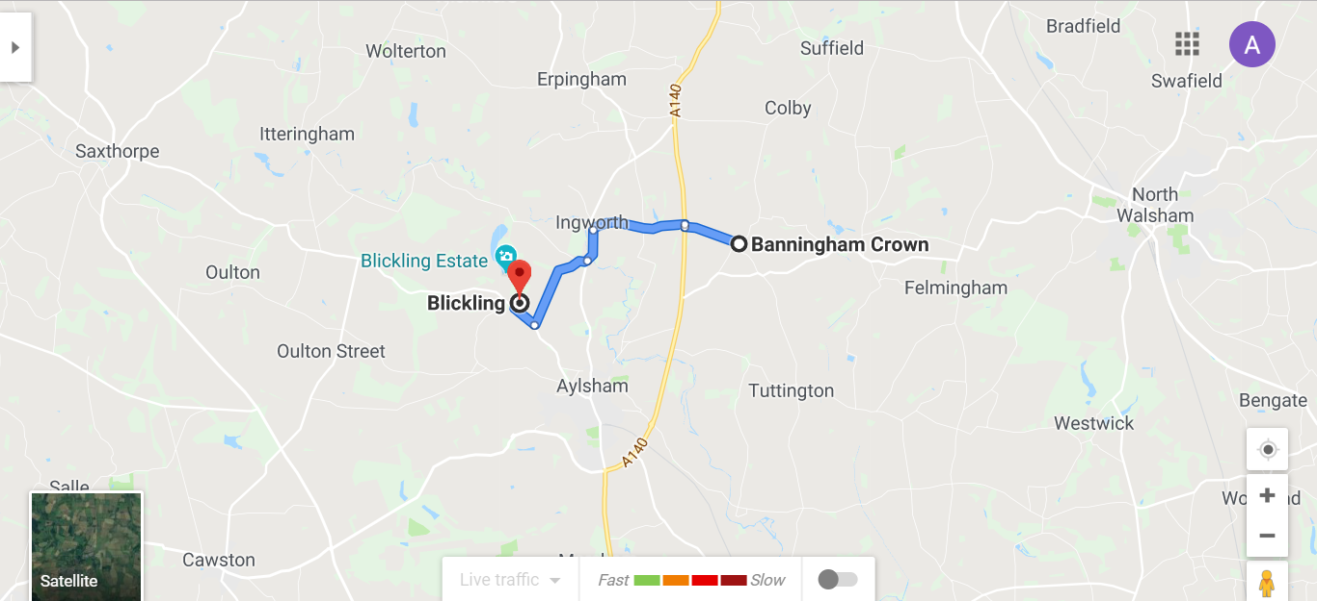
http://www.banninghamcrown.co.uk/contact-us.aspx

Venue contact: Tel: 01263 733534 Alison Plenderleith 07429 523183

