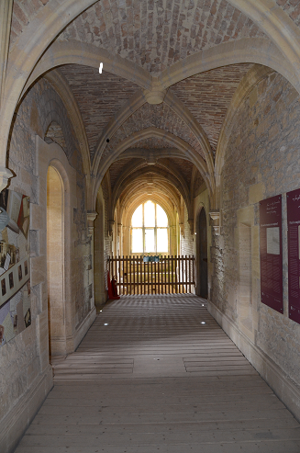

The day’s course will consider in depth three aspects of building conservation:

* The care and repair of historic stonework
* The care and repair of historic brickwork
* Understanding historic mortars and the use of lime in conservation

The venue has been carefully chosen as it represents a fine example of 19th century stonework. This country house is unique in being able to be viewed in its unfinished state with all its constructional details observable. The house is in an 18th century landscaped parkland and construction work started in 1858 for the owner William Leigh. The house is a fine example of the Gothic Revival style of architecture. William Leigh died in 1873 and all work stopped with a completed shell and only a small part of the interior fitted out. His successors abandoned the project as it was too expensive to complete or demolish and replace with a new building. During the 20th century the finished parts of the house were used but it was mainly abandoned to the elements and was then purchased by Stroud District Council and leased to the Woodchester Mansion Trust in 1992. The house is now open to the public and is also used for training courses in stone conservation and craftsmanship and there is a continuing long term programme of repair. The day will include formal Power Point presentations, material handling sessions and first hand observations of the building and the details of its construction.

Kevin Stubbs will be presenting. A regular presenter on Historic Buildings Kevin Stubbs is a Historic Buildings Consultant and comes with a background of education, archaeology and building conservation. He was Director of Archaeology for the Test Valley in Hampshire and later moved to Hampshire County Council to join the Historic Buildings Bureau, where he became the Principal Buildings Conservation Officer for the County. For eleven years he acted as the Director of a Conservation Centre and now runs his own Historic Building Consultancy and Training Company.

**Main Themes**

* The History and Architectural Development of Stone Structures
* Care and Repair of Historic Stonework
* The History of Brickmaking and Building in Brick
* Interpreting Historic Brickwork
* Care and Repair of Historic Masonry structures and Selection of Mortars

**Web:** [www.cpdessentials.co.uk](http://www.cpdessentials.co.uk)

CPD essentials 2016

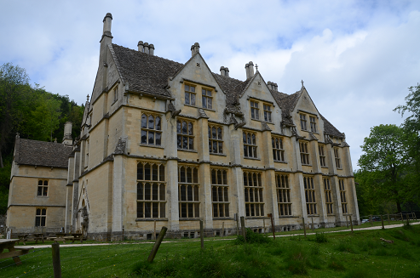

**Historic Buildings**

**CPD seminar**

**Care & repair of historic masonry structures**

**When:** 15 July 2016

**Where:** Woodchester Mansion, Stround

**Time:** 1000 - 1630

**Cost:** £120 + VAT (£144) to include refreshments, lunch and delegate notes

