Residential Inspections and Reports
CPD Seminar
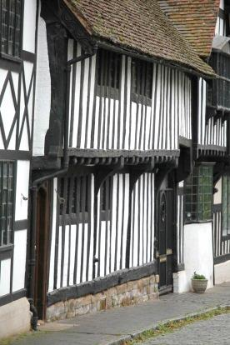
How old is that house?
16 March 2018, Wimborne, Dorset
A professional’s guide to assessing the age of a dwelling
This one-day course is designed to assist property professionals in assessing the age of a residential property based on its external appearance. The course will describe and illustrate distinctive dating characteristics across the full spectrum of the nation’s housing stock from medieval dwellings to the current day.  - What to look out for: key dating characteristics on individual dwellings  - Recognising distinct construction periods: the age bands  - The social and technological influences on construction and appearance  Accurate assessment of property age is fundamental to effective appraisal and reporting and this course sets out an efficient process for the property professional to achieve that objective by using the external appearance of a dwelling. The centre of the historic town of Wimborne Minster has been carefully selected for the course, with a fascinating range of property ages and types within a few minutes walk of the venue.  The day will include presentations extensively illustrated with regional and national examples and a short walk around the centre of Wimborne for first hand observations of local buildings to examine the practical application of the principles described. Suitable weather-related clothing is recommended!  The course will be presented by Philip Santo FRICS, a regular presenter of residential survey and valuation topics, who has acted as a consultant for RICS on a number of projects, and is the author of the acclaimed volume “Inspections and Reports on Dwellings: Assessing Age” *, described by the RICS Bookshop as a “must-read book for building surveying professionals.”  Main Themes  - Using architectural styles and influences to date dwellings  - Dating Elizabethan, timber-framed and other historic properties  - Differentiating Georgian from Regency, and Victorian from Edwardian  - Understanding the visual effects of legislation on the urban streetscape  - The impact of the Arts and Craft, Art Deco, and Garden City Movements  - The consequences of post-war redevelopment on design and appearance  - Utilising changing town planning theories to assess date of construction  - Dating blocks of flats from Victorian to modern times  - Recognising and dating the distinctive phases of post-WW2 housing | 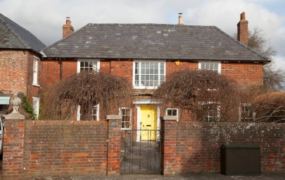  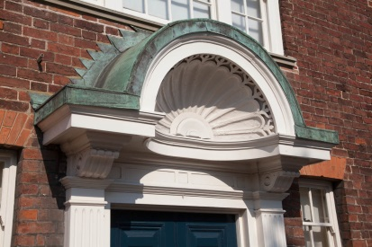  When: 16 March 2018  Where: Olive Branch, Wimborne  Time: 1000 - 1630  Cost: £120 + VAT (£144) to include lunch and delegate notes  Contact: Alison Plenderleith www.cpdessentials.co.uk  07429 523183

“A very worthwhile course.”
“Very informative and interesting ... Philip Santo is very good, with a genuine interest in the topic.”
* all delegates will be entitled to a discount of 20% off the price of the book

