The day’s course will consider in depth three aspects of building conservation:

* The care and repair of historic stonework
* The care and repair of historic brickwork
* Understanding historic mortars and the use of lime in conservation

The venue has been carefully chosen as it represents a fine example of Medieval and later stonework. This major and very impressive medieval castle was extensively reconstructed in the mid to late 14th century. In the 17th century the domestic range of the castle was in poor condition and was remodelled with all the comforts of a country house. It was further updated in the 18th century including the addition of a prestigious coach house in the grounds where we are holding the course. In 1871 fire extensively damaged the great hall and it was reconstructed to a Victorian taste. The buildings display masonry of many periods and centuries of repair including 20th century work. The day will include formal Power Point presentations, material handling sessions and first hand observations of some of the buildings.

Kevin Stubbs will be presenting. A regular presenter on Historic Buildings Kevin Stubbs is a Historic Buildings Consultant and comes with a background of education, archaeology and building conservation. He was Director of Archaeology for the Test Valley in Hampshire and later moved to Hampshire County Council to join the Historic Buildings Bureau, where he became the Principal Buildings Conservation Officer for the County. For eleven years he acted as the Director of a Conservation Centre and now runs his own Historic Building Consultancy and Training Company.

**Main Themes**

* The History and Architectural Development of Stone Structures
* Care and Repair of Historic Stonework
* The History of Brickmaking and Building in Brick
* Interpreting Historic Brickwork
* Care and Repair of Historic Masonry structures and Selection of Mortars

**Web:** [www.cpdessentials.co.uk](http://www.cpdessentials.co.uk)

CPD essentials 2016

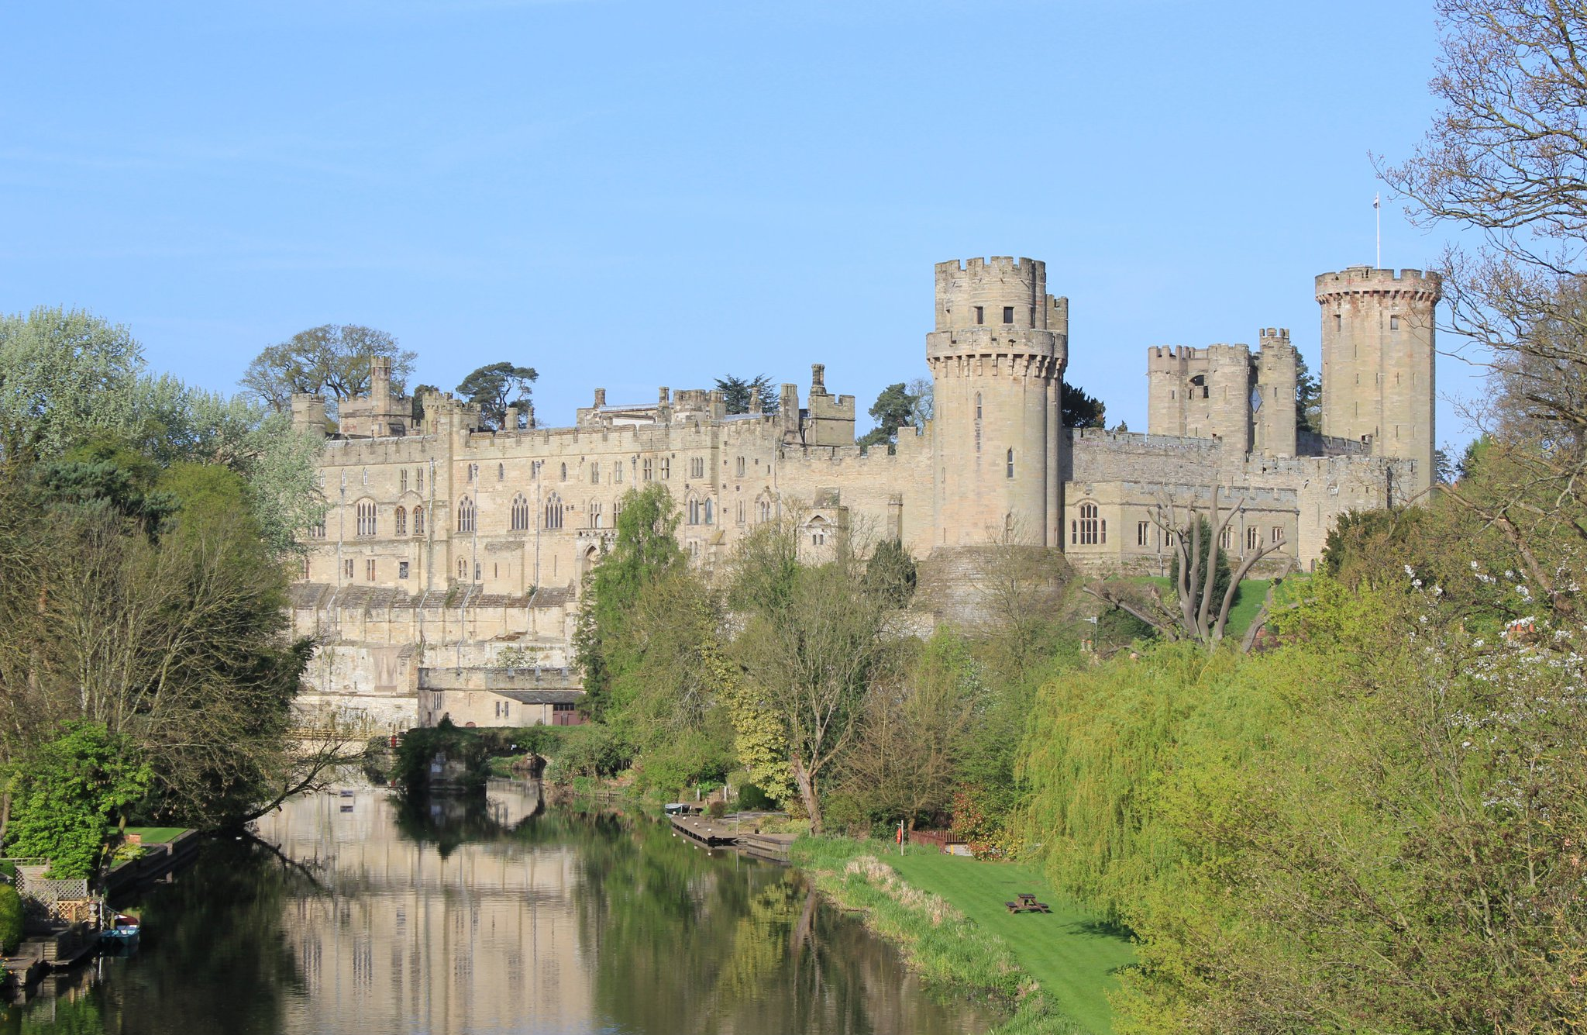

**Historic Buildings**

**CPD seminar**

**Care & repair of historic masonry structures**

**When:** 11 November 2016

**Where:** Warwick Castle, Warwick

**Time:** 1000 - 1630

**Cost:** £120 + VAT (£144) to include refreshments, lunch and delegate notes

