**When:** 15 March 2018

**Where:** Holiday Inn Brentford and Syon Park

**Time:** 0930 - 1700

**Cost:** £125 + VAT (£150) to include refreshments, lunch, entry to Syon House & delegate notes

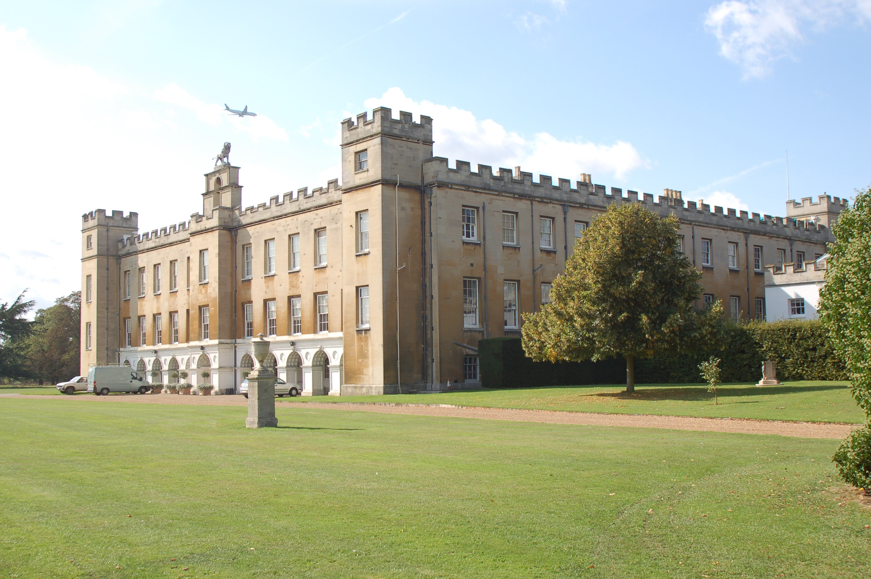

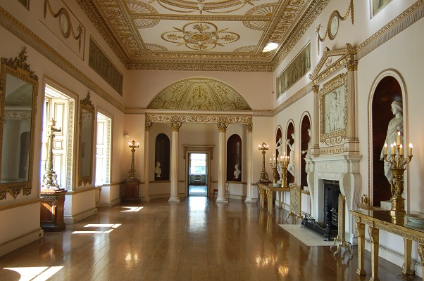

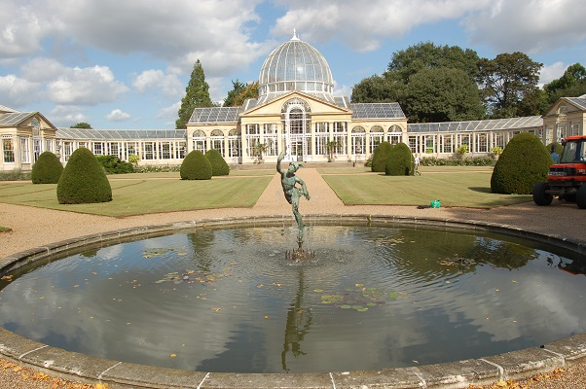

The day’s course will consider in depth three aspects of building conservation:

* The care and repair of historic stonework
* Understanding historic mortars and the use of lime in conservation
* The historic Fabric of Syon Park including decorative plasters and finishes and glass.

The venue has been carefully chosen as the house represents fine examples of a country house with a long history of adaptation and change from a medieval monastic establishment to a grand 18th century estate. The building was mainly constructed in stone and was refaced in Bath Stone in the 1820s. The interior of the house reflects changing ideas of decoration and comfort with one of the finest examples of decorative plasterwork by Robert Adam to be found in the south of England. The Great Conservatory designed by Charles Fowler was completed in 1827 and was the first to be built of metal and glass on a large scale.

The day will include formal Power Point presentations, material handling sessions and first hand observations of some of the main buildings and their conservation problems.

Kevin Stubbs will be presenting. A regular presenter on Historic Buildings Kevin Stubbs is a Historic Buildings Consultant and comes with a background of education, archaeology and building conservation. He was Director of Archaeology for the Test Valley in Hampshire and later moved to Hampshire County Council to join the Historic Buildings Bureau, where he became the Principal Buildings Conservation Officer for the County. For eleven years he acted as the Director of a Conservation Centre and now runs his own Historic Building Consultancy and Training Company.

Full details available on the website

**Web:** [www.cpdessentials.co.uk](http://www.cpdessentials.co.uk)

CPD 2018

**Historic Buildings**

**CPD seminar**

**Care & repair of historic masonry structures**

**Syon Park, Brentford, 15 March 2018**

