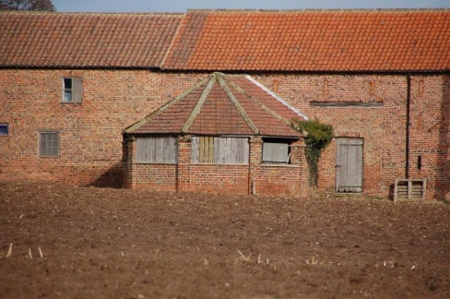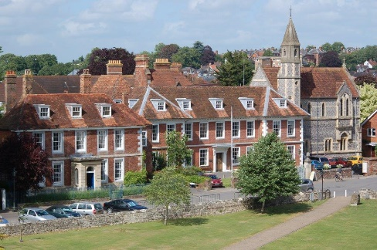

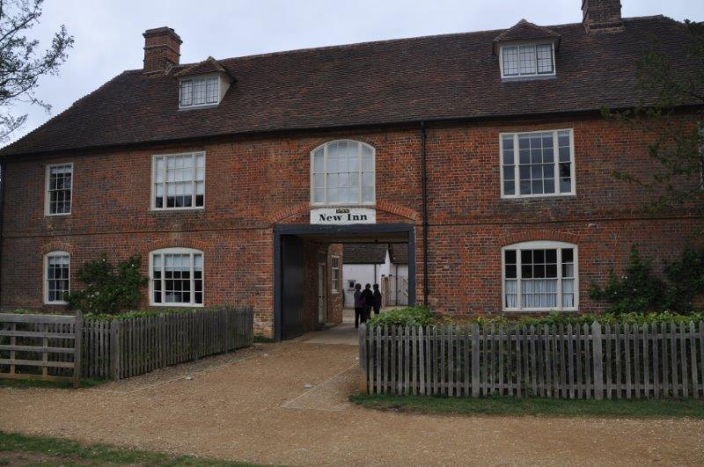

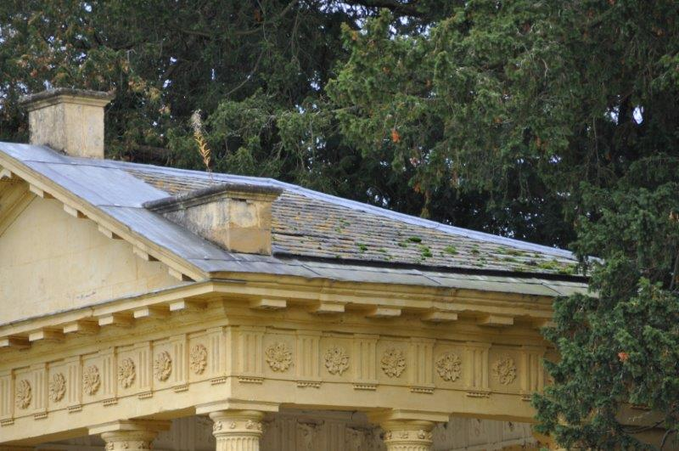

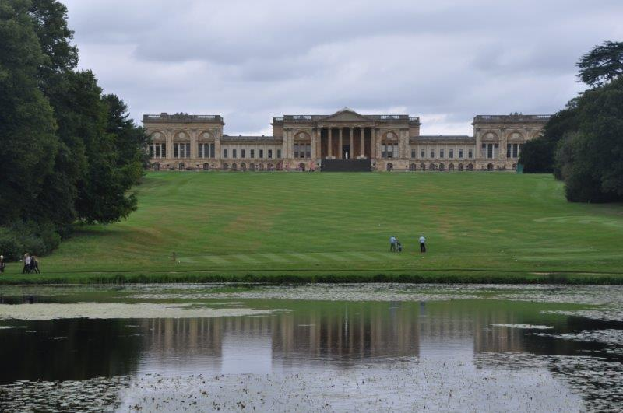

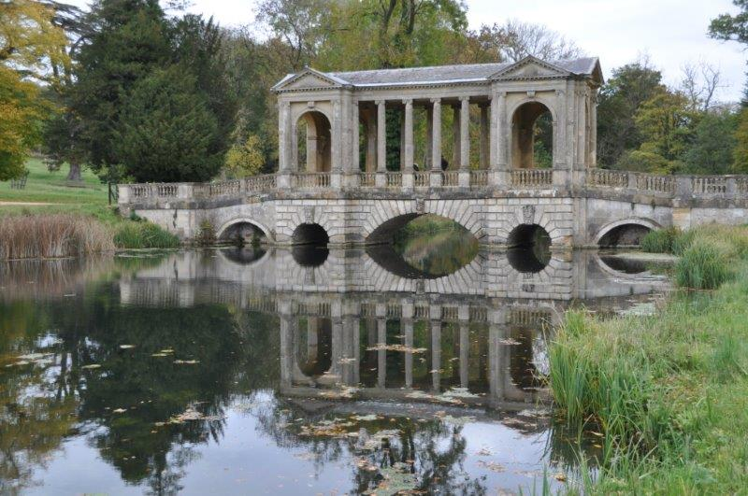

**Historic Buildings**

**CPD seminar**

**Historic timber structures and roof coverings**

The day’s course will consider in depth three aspects of building conservation.

* The care and repair of historic timber frames and roof structures
* The range of historic roof coverings
* Problems of decay and methods of repair

The venue has been carefully chosen as the building itself is multi-period ranging from the medieval to the early 20th century. It has examples of mainly clay tiled roofs, and adjacent in the Cathedral Close are a number of excellent 18th century buildings with a variety of roof coverings. The day will include formal Power Point presentations, material handling sessions and first hand observations of the buildings.

Kevin Stubbs will be presenting. A regular presenter on Historic Buildings Kevin Stubbs is a Historic Buildings Consultant and comes with a background of education, archaeology and building conservation. He was Director of Archaeology for the Test Valley in Hampshire and later moved to Hampshire County Council to join the Historic Buildings Bureau, where he became the Principal Buildings Conservation Officer for the County. For eleven years he acted as the Director of a Conservation Centre and now runs his own Historic Building Consultancy and Training Company.

**Main Themes**

**The History and Development of Historic Roof Structures**

* The historic development of timber frames and roof structures
* Causes of decay and failure including mechanical failure, rot and insect attack.
* Approach to structural repairs, selection and use of materials and techniques.
* Case Studies

**Historic Roof Coverings**

* Thatch, problems of decay, selection of materials, fire and fire mitigation.
* Shingle, decay and repair including selection of materials.
* Tile, history, manufacture, problems of decay and repair.
* Slate, Metamorphic and stone, history and quarrying, problems of failure, selection of materials and repair.
* Lead, flashings and lead sheet, problems including under sheet corrosion, acid attack, correct detailing and installation.
* Other sheet materials and rainwater disposal.
* Chimney pots and roofscapes

**Web:** [www.cpdessentials.co.uk](http://www.cpdessentials.co.uk) r

CPD essentials 2016

**When:** 4 November 2016

**Where:** The New Inn, Stowe, Stowe House

**Time:** 1000 - 1630

**Cost:** £120 + VAT (£144) to include refreshments, lunch and delegate notes

