The day’s course will consider in depth three aspects of building conservation:

* The care and repair of historic stonework
* The care and repair of historic brickwork
* Understanding historic mortars and the use of lime in conservation

The venue has been carefully chosen as it represents a fine example of 15th century and later stonework. This major and very large country house developed from a palace built by Archbishop Bourchier from 1456, and later extended by various archbishops of Canterbury. In 1538 Archbishop Cranmer was forced to give the property to Henry VIII and it remained in royal ownership though leased to a number of favourites until it was acquired by the Sackville family in 1605. The house remained in the ownership of the family until 1946 when it was given to the National Trust though the family still live in part of it. The buildings display masonry of many periods as it was modified and the interiors revamped in the 17th and 18th centuries. There has also been many phases of repair including major restoration of the Kentish Ragstone walls in the 20th century and now a large scale conservation project including not only the building but also its contents. The day will include formal Power Point presentations, material handling sessions and first hand observations of some of the buildings.

Kevin Stubbs will be presenting. A regular presenter on Historic Buildings Kevin Stubbs is a Historic Buildings Consultant and comes with a background of education, archaeology and building conservation. He was Director of Archaeology for the Test Valley in Hampshire and later moved to Hampshire County Council to join the Historic Buildings Bureau, where he became the Principal Buildings Conservation Officer for the County. For eleven years he acted as the Director of a Conservation Centre and now runs his own Historic Building Consultancy and Training Company.

**Main Themes**

* The History and Architectural Development of Stone Structures
* Care and Repair of Historic Stonework
* The History of Brickmaking and Building in Brick
* Interpreting Historic Brickwork
* Care and Repair of Historic Masonry structures and Selection of Mortars

**Web:** [www.cpdessentials.co.uk](http://www.cpdessentials.co.uk)

CPD 2016

**When:** 18 November 2016

**Where:** NT Knole House, Sevenoaks

**Time:** 1000 - 1630

**Cost:** £120 + VAT (£144) to include refreshments, lunch and delegate notes

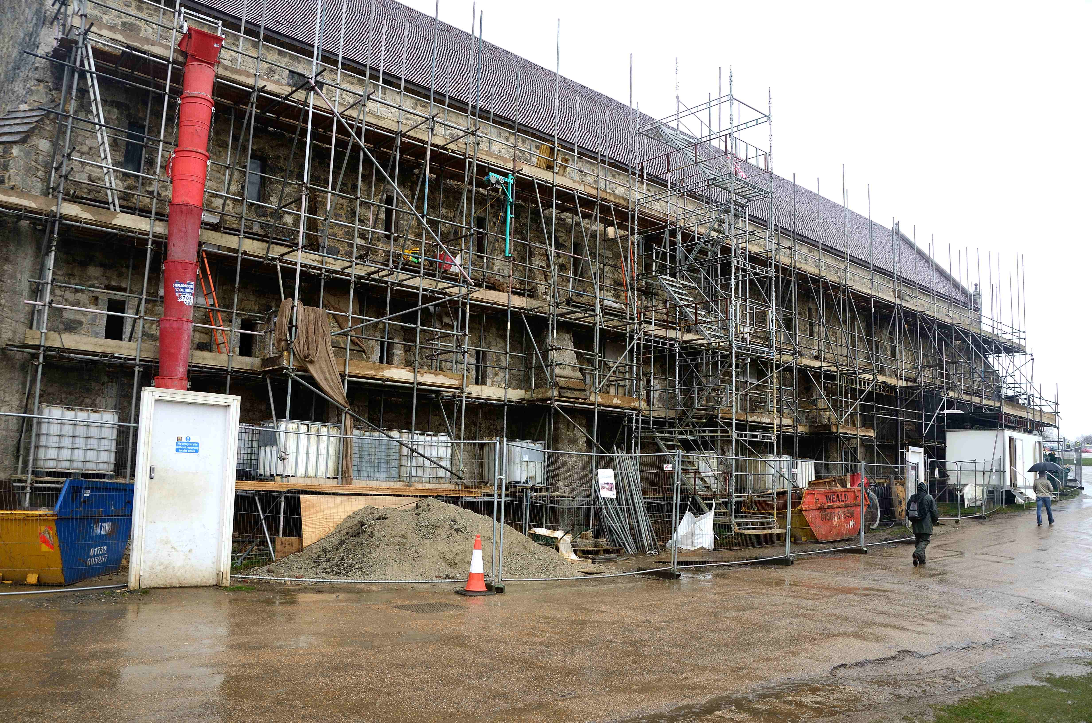

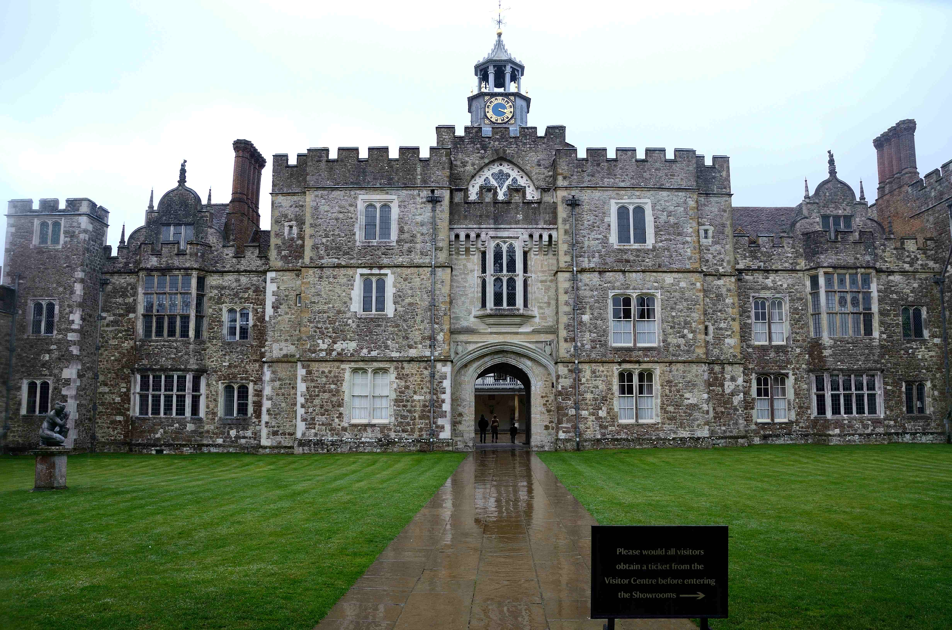

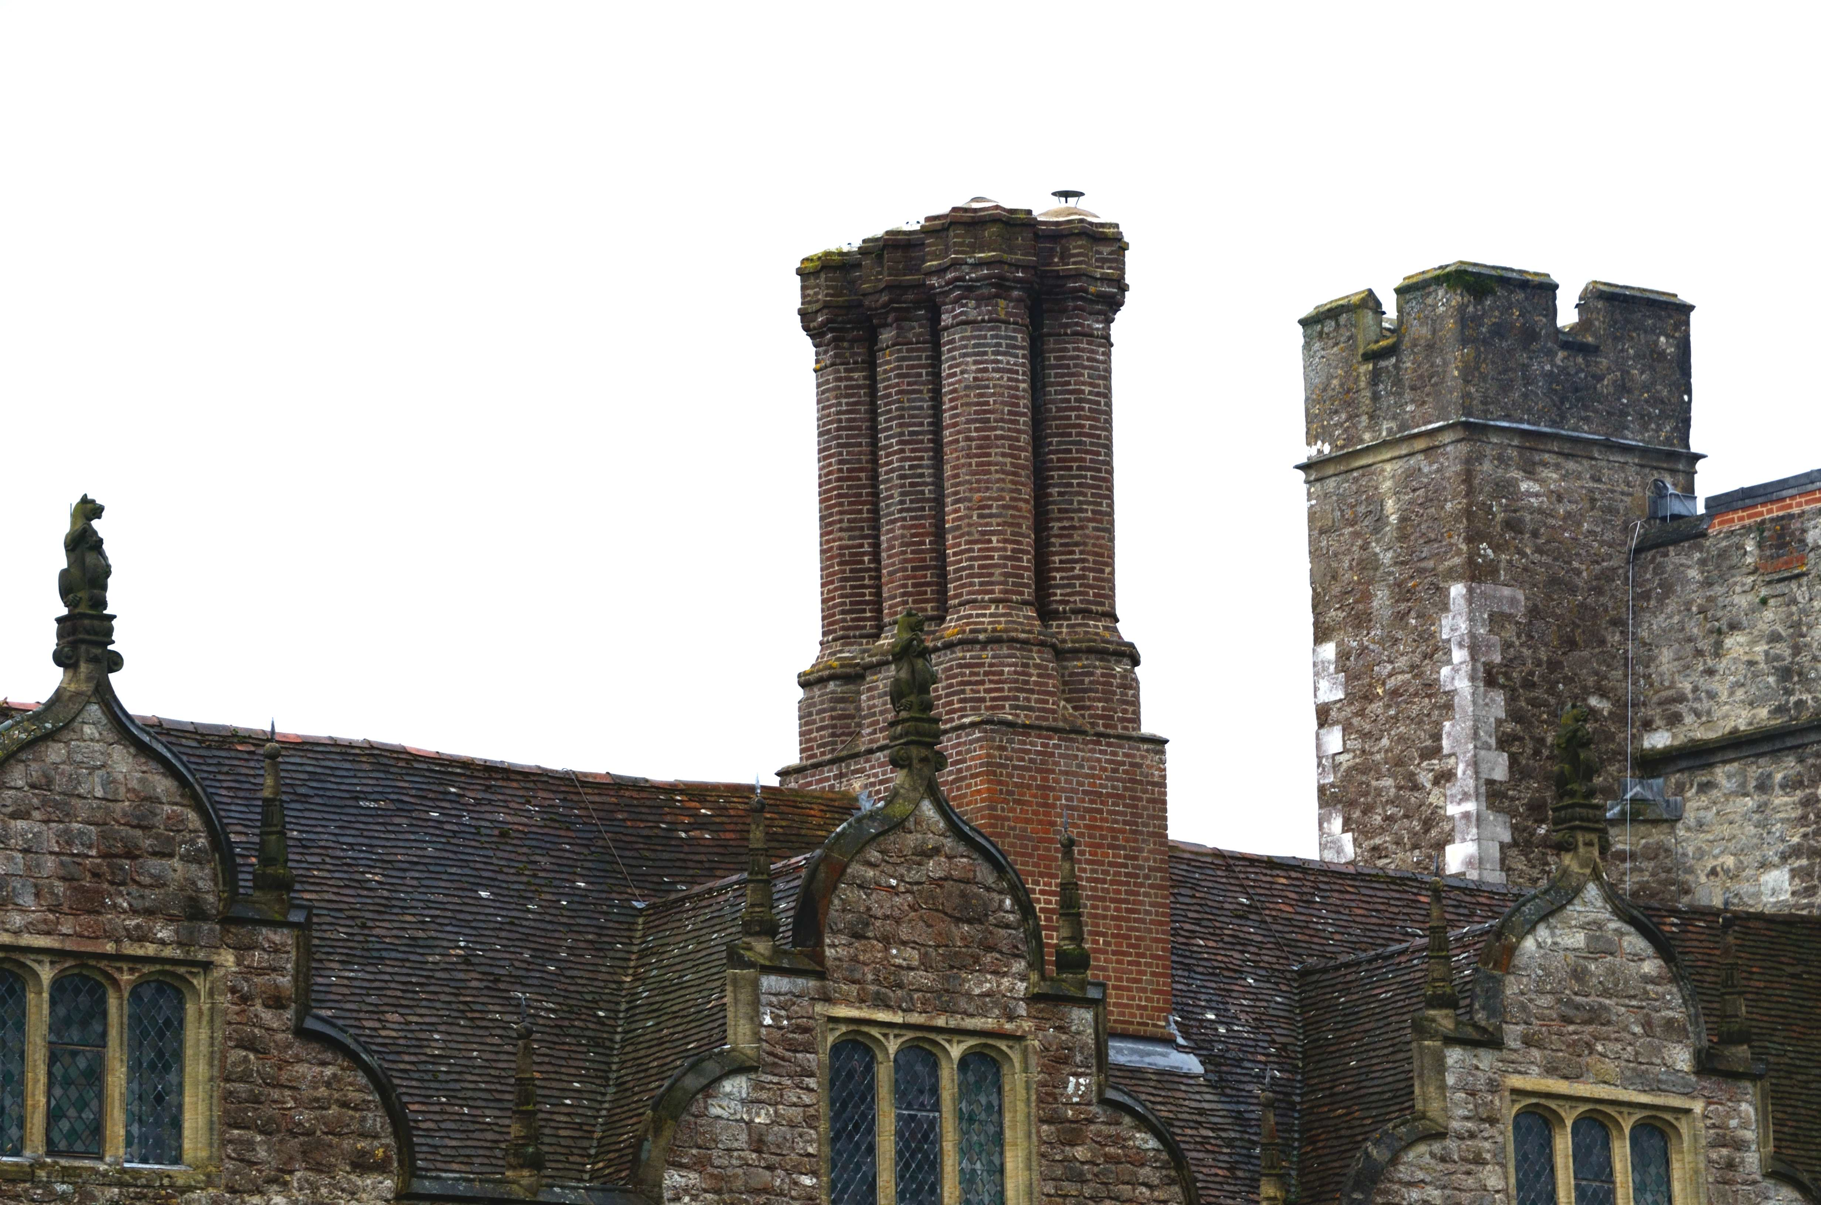

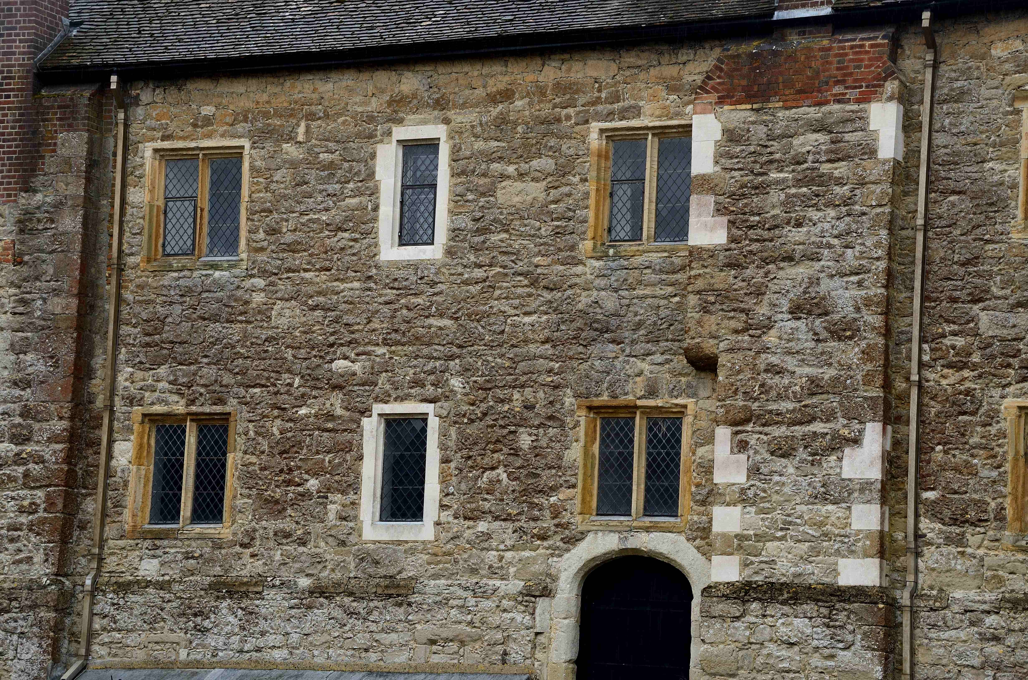

**Historic Buildings**

**CPD seminar**

**Care & repair of historic masonry structures**

