Historic Building CPD Day
21 October 2016, Salisbury Museum

Thank you for booking a place at the above event – the details are as follows:

Start time: Registration from 0930 with coffee and refreshments
Start time 1000
Finish: 1630

Lunch is included – please advise any particular dietary requirements

Venue and directions
The Salisbury Museum, The King’s House, 65 The Close, Salisbury, SP1 2EN
You can find The Salisbury Museum in the glorious setting of the Cathedral Close, opposite the West front of Salisbury Cathedral. Easiest access to the Close is via New Street
By car: Follow city centre signs to Cathedral Close (there is a £6 parking charge which you pay at the kiosk on entering the close). There is a park and ride scheme and alternative car parks http://www.wiltshire.gov.uk/parkingtransportandstreets/carparking/parkandride.htm
By train: SWT and GW to Salisbury. Buses to city centre or 1.2 km level walk.
By bus: Alight at city centre, or Exeter Street.
The Museum is sign-posted in the City and the Close.
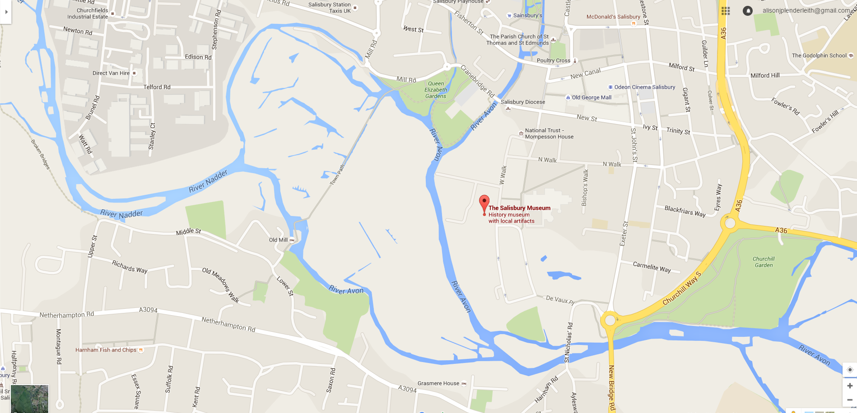

Venue telephone 01722 332151
www.salisburymuseum.org.uk
Alison Plenderleith 07429 523183

