Commercial essentials
24 November 2016, Basingstoke

Thank you for booking a place at the above event – the details are as follows:

Start time: Registration from 0900 with arrival refreshments
Start time 0925
Finish: 1700

Lunch is included – please advise any particular dietary requirements

Venue:
Holiday Inn, Grove Road, Basingstoke, RG21 3EE
You will be directed from reception

Free parking

Directions
Exit M3 junction 6 towards A33/A339 Basingstoke, Newbury, Alton, Reading. At the roundabout take the 1st ex

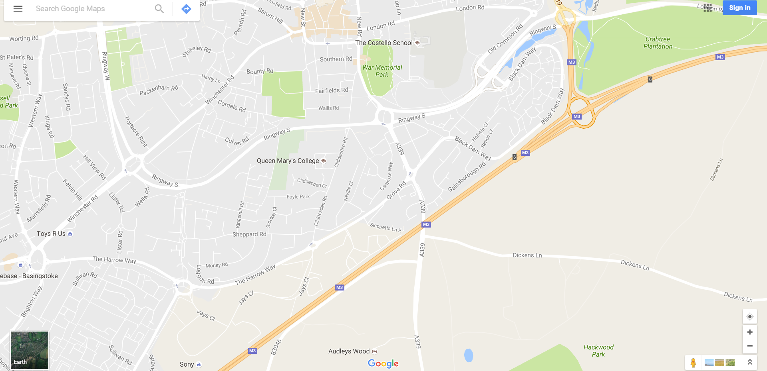

Contact details
Alison Plenderleith 07429 523183 alison@cpdessentials.co.uk
Venue: 0871 942 9004

