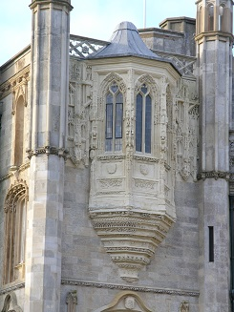

**When:** 22 June 2018

**Where:** Highcliffe Castle

**Time:** 0930 - 1700

**Cost:** £125 + VAT (£150) to include refreshments, lunch delegate notes

**Parking:** At Steamer point with 10 min walk £7.00 for the day. Highcliffe Castle car park limited to 4 hours

The day’s course will consider in depth three aspects of building conservation:

* The care and repair of historic stonework
* Care and repair of historic masonry structures and selection of mortars
* The historic fabric of Highcliffe Castle

The venue has been carefully chosen as it represents a fine examples of a Grade 1 country house with a history of two disastrous fires, dereliction, and the battle to save it for future generations. The building is the product of a collaboration between Lord Stuart de Rothesay and his architect William Donthorn in 1831 in the picturesque Gothic style. Lord Stuart had a career as a diplomat and spent two periods as British Ambassador in Paris where he amassed a vast collection of architectural salvage including medieval and 16th century stonework, stained glass, panelling, antique furniture and tapestries. The castle was bought in 1967 for development and shortly after suffered two fires and then followed 20 years of vandalism and dereliction. The local council compulsorily purchased the property and in 1990 temporary works were undertaken to prevent further decay supported by a £2.9 million Lottery Fund grant. The building now has a watertight shell with new roofs and well restored exterior.

The day will include formal Power Point presentations, material handling sessions and first hand observations of the building.

Kevin Stubbs will be presenting. A regular presenter on Historic Buildings Kevin Stubbs is a Historic Buildings Consultant and comes with a background of education, archaeology and building conservation. He was Director of Archaeology for the Test Valley in Hampshire and later moved to Hampshire County Council to join the Historic Buildings Bureau, where he became the Principal Buildings Conservation Officer for the County. For eleven years he acted as the Director of a Conservation Centre and now runs his own Historic Building Consultancy and Training Company.

Full details available on the website

**Web:** [www.cpdessentials.co.uk](http://www.cpdessentials.co.uk)

CPD 2018

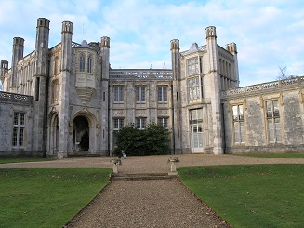

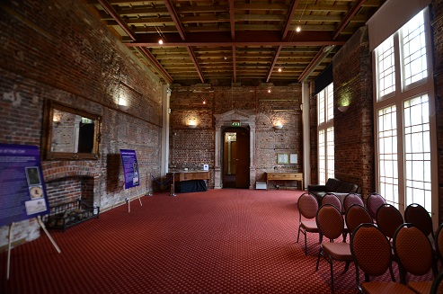

**Historic Buildings**

**CPD seminar**

**Care & repair of historic masonry structures**

**Highcliffe Castle, Christchurch, Friday 22 June**

