The day’s course will consider in depth three aspects of building conservation:

* The care and repair of historic stonework
* The care and repair of historic brickwork
* Understanding historic mortars and the use of lime in conservation

The venue has been carefully chosen as it represents a fine example of Medieval and later stonework. The abbey was one of the largest and wealthiest in Medieval Europe and displays good examples of stone construction from 1132 to the 16th century Dissolution of the monastery’s. Its isolated location saved it from total destruction and its inclusion as a romantic ruin in the 18th century landscaped park and water gardens ensured its survival today as the most complete monastic ruin in the country. The site also contains the late 16th century Fountains Hall, a number of 18th century garden buildings and statues and the fine 19th century church designed by Burges. The complex has the high status of a World Heritage Site. The day will include formal Power Point presentations, material handling sessions and first hand observations of part of the abbey buildings.

Kevin Stubbs will be presenting. A regular presenter on Historic Buildings Kevin Stubbs is a Historic Buildings Consultant and comes with a background of education, archaeology and building conservation. He was Director of Archaeology for the Test Valley in Hampshire and later moved to Hampshire County Council to join the Historic Buildings Bureau, where he became the Principal Buildings Conservation Officer for the County. For eleven years he acted as the Director of a Conservation Centre and now runs his own Historic Building Consultancy and Training Company.

**Main Themes**

* The History and Architectural Development of Stone Structures
* Care and Repair of Historic Stonework
* The History of Brickmaking and Building in Brick
* Interpreting Historic Brickwork
* Care and Repair of Historic Masonry structures and Selection of Mortars

**Web:** [www.cpdessentials.co.uk](http://www.cpdessentials.co.uk)

CPD essentials 2016

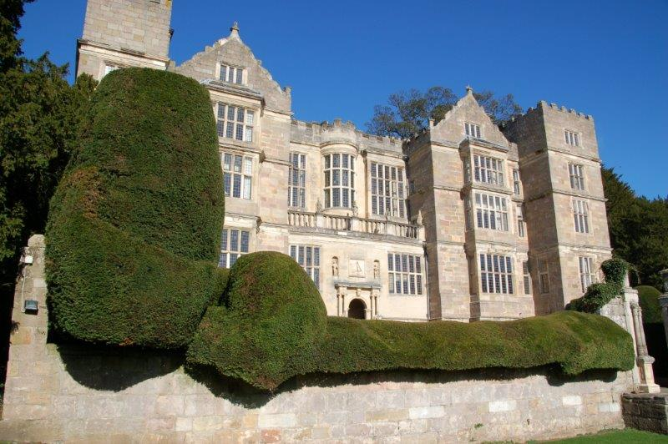

**Historic Buildings**

**CPD seminar**

**Care & repair of historic masonry structures**

**When:** 9 September 2016

**Where:** Fountains Abbey, Ripon

**Time:** 1000 - 1630

**Cost:** £120 + VAT (£144) to include refreshments, lunch and delegate notes

