**When:** 10 July 2018

**Where:** Drewe Arms and Castle Drogo

**Time:** 0930 - 1700

**Cost:** £125 + VAT (£150) to include refreshments, lunch, entry to Castle Drogo, Hard hat tour and delegate pack

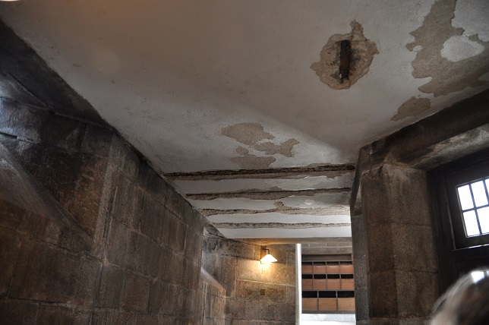

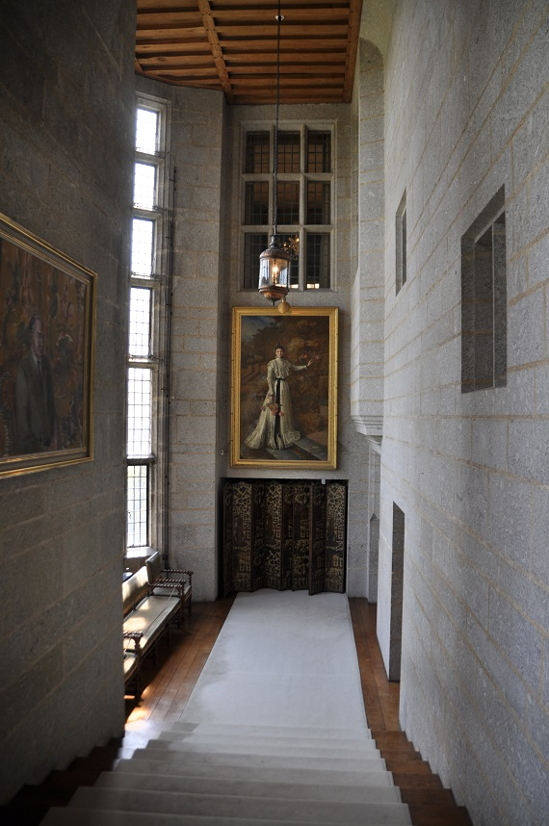

The day’s course will consider in depth three aspects of building conservation:

* The care and repair of historic stonework
* Understanding historic mortars and the use of lime in conservation
* The historic Fabric of Castle Drogo including the inherent problems of the early 20th century construction.

The venue has been carefully chosen as the house represents fine examples of a 20th century country house designed by Sir Edwin Lutyens. The building was constructed in the local granite stone and designed to look like a medieval castle. It has a flat roof of early reinforced concrete with an asphalt surface and the building has had problems of water ingress ever since it was completed. The interior of the house reflects the contemporary Arts and Crafts fashion with very high quality design and craftsmanship.

The day will include first hand observations of the building and the current conservation project in the afternoon preceded by formal Power Point presentations off site in the morning

Kevin Stubbs will be presenting. A regular presenter on Historic Buildings Kevin Stubbs is a Historic Buildings Consultant and comes with a background of education, archaeology and building conservation. He was Director of Archaeology for the Test Valley in Hampshire and later moved to Hampshire County Council to join the Historic Buildings Bureau, where he became the Principal Buildings Conservation Officer for the County. For eleven years he acted as the Director of a Conservation Centre and now runs his own Historic Building Consultancy and Training Company.

Full details available on the website

**Web:** [www.cpdessentials.co.uk](http://www.cpdessentials.co.uk)

CPD 2018

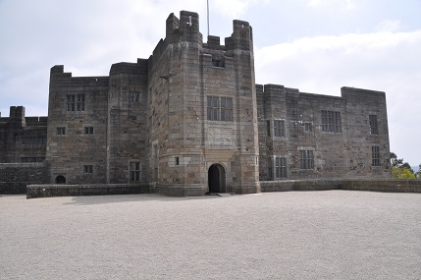

**Historic Buildings**

**CPD seminar**

**Care & repair of historic masonry**

**Castle Drogo, Drewsteighton, Devon**

