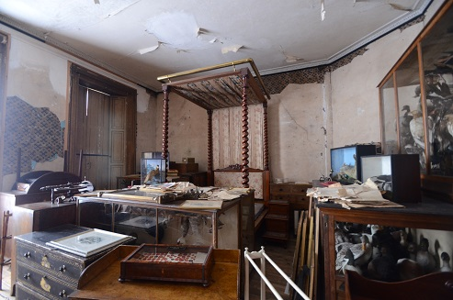

The day’s course will consider in depth three aspects of building conservation:

* The care and repair of historic brickwork
* Understanding historic mortars and the use of lime in conservation
* The historic fabric of Calke Abbey estate

The venue has been carefully chosen as it represents a fine example of a country estate with a large complex of associated buildings constructed in brick. The historic core of the house was constructed in the 1573 on the site of a medieval abbey. The house that we see today is a remodelling in stone dating to1702 shortly followed by a grand stable block and estate buildings constructed in brick in 1712. A riding school was added in 1767 reflecting the growing interest in horse racing. In 1807 William Wilkins was commissioned to upgrade the main façade of the house with the addition of a Grecian portico. There were a number of small changes in the 19th century and then nothing in the 20th century as the house and estate slid into a gentle decline. The estate was in the ownership of the Harpur family from 1622 and the last of the direct line of the family died in 1999.The house and a large part of the estate was rescued by the National Trust in 1984 via an arrangement with the government on death duties and a grant of £4.5 million from the National Lottery Fund.

The day will include formal Power Point presentations, material handling sessions and first hand observations of the building.

Kevin Stubbs will be presenting. A regular presenter on Historic Buildings Kevin Stubbs is a Historic Buildings Consultant and comes with a background of education, archaeology and building conservation. He was Director of Archaeology for the Test Valley in Hampshire and later moved to Hampshire County Council to join the Historic Buildings Bureau, where he became the Principal Buildings Conservation Officer for the County. For eleven years he acted as the Director of a Conservation Centre and now runs his own Historic Building Consultancy and Training Company.

Full details available on the website

**Web:** [www.cpdessentials.co.uk](http://www.cpdessentials.co.uk)

CPD 2018

**When:** 20 July 2018

**Where:** Calke Abbey

**Time:** 0930 - 1700

**Cost:** £125 + VAT (£150) to include refreshments, lunch delegate notes

**Parking:** Small parking fee payable

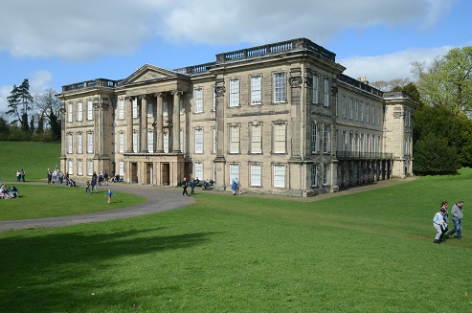

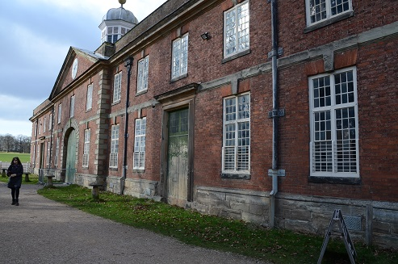

**Historic Buildings**

**CPD seminar**

**Care & repair of historic brickwork**

**Calke Abbey, Derby, Friday 20 July**

