**Historic Buildings**

**CPD seminar**

**Care and repair of historic timber roof structures and historic brickwork**

**When:** 7 April 2017

**Where:** Weybrook Park Golf Club and the Vyne National Trust, Basingstoke

**Time:** 1000 - 1630

**Cost:** £120 + VAT (£144) to include refreshments, lunch and delegate notes

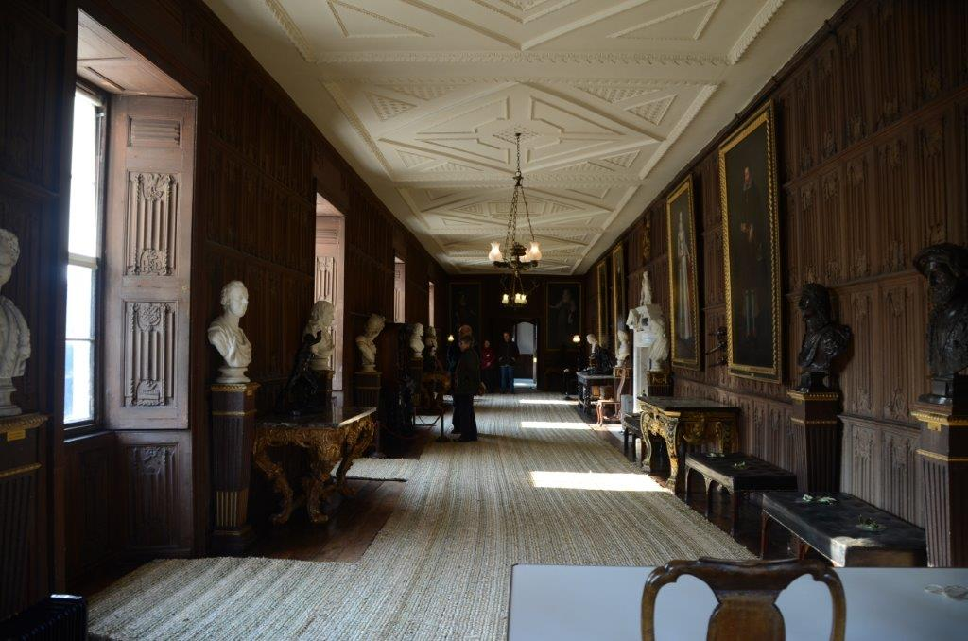

**The Vyne 7 April 2017**

The venue has been carefully chosen as The Vyne represents a fine example of a 16th century country house which was modified and improved in later centuries. The building is at present undergoing a major programme of repair at roof level and public viewing areas have been provided on the scaffolding. This gives a unique opportunity to observe the historic fabric at close quarters and understand some of the repair problems. The day will include formal Power Point presentations, to be held in the nearby Golf Club House in the morning and first hand observations of The Vine in the afternoon to include a visit to roof level to view the ongoing programme of repairs.

The day’s course will consider in depth three aspects of building conservation:

* The care and repair of historic timber frames and roof structures
* The care and repair of historic brickwork
* Problems of decay and methods of repair

Kevin Stubbs will be presenting. A regular presenter on Historic Buildings Kevin Stubbs is a Historic Buildings Consultant and comes with a background of education, archaeology and building conservation. He was Director of Archaeology for the Test Valley in Hampshire and later moved to Hampshire County Council to join the Historic Buildings Bureau, where he became the Principal Buildings Conservation Officer for the County. For eleven years he acted as the Director of a Conservation Centre and now runs his own Historic Building Consultancy and Training Company.

**Main Themes**

* The historic development of timber frames and roof structures
* Causes of decay and failure including mechanical failure, rot and insect attack.
* Approach to structural repairs, selection and use of materials and techniques.
* Tile, history, manufacture, problems of decay and repair.
* Lead, flashings and lead sheet, problems including under sheet corrosion, acid attack, correct detailing and installation.

[alison@cpdessentials.co.uk](mailto:alison@cpdessentials.co.uk)

**Web:** [www.cpdessentials.co.uk](http://www.cpdessentials.co.uk)

CPD essentials 2017

