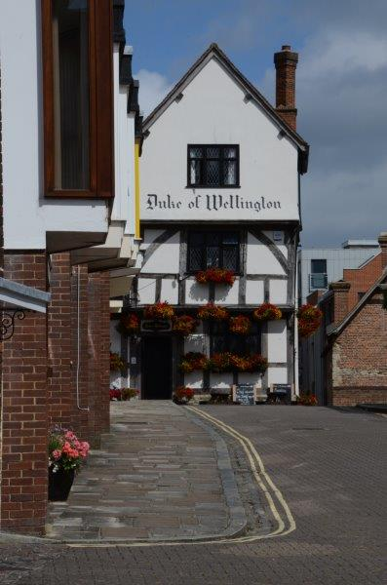

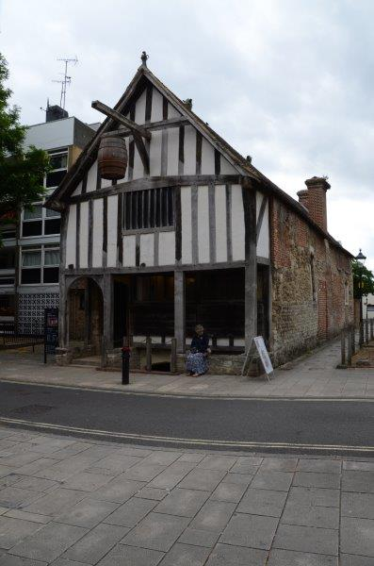

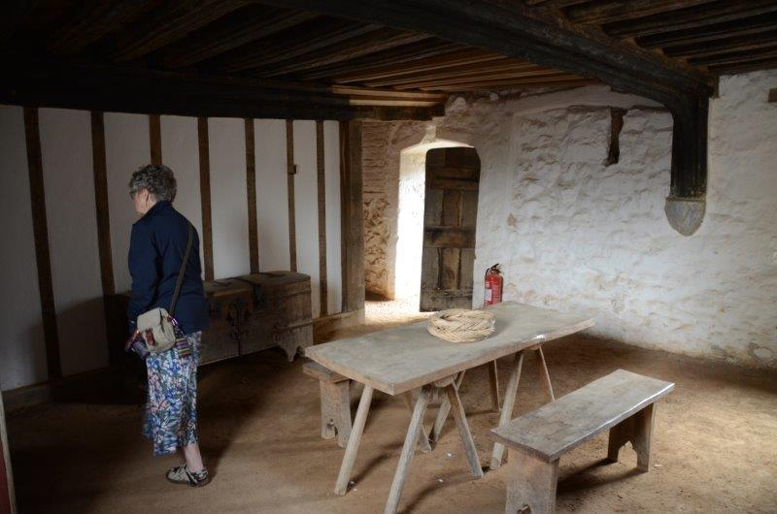

**When:** 21 July 2017

**Where:** Duke of Wellington, Southampton

**Time:** 1000 - 1630

**Cost:** £120 + VAT (£144) to include refreshments, lunch and delegate notes

Please complete the booking form at [www.cpdessentials.co.uk](http://www.cpdessentials.co.uk) or contact [alison@cpdessentials.co.uk](mailto:alison@cpdessentials.co.uk)

The day’s course will consider in depth three aspects of building conservation.

* The care and repair of historic timber frames
* The care and repair of historic stonework
* Problems of decay and methods of repair

Our venue, the Duke of Wellington now a public house was constructed in the late medieval period as a timber framed shop and house over a stone undercroft. The building was partly damaged during the war but was restored shortly after. The meeting room we are using is the upper part of the medieval open hall and displays its very fine timber frame. At 2pm we will visit The Medieval Merchant’s House which is the earliest and most complete in the country. It dates from 1290 and has been restored, including reproduction furnishings to be presented as it would have looked in the late 13th/early 14th century. It has both stone and timber frame in its construction and the roof restored to its original form with Delabole slate and glazed tile ridge, finials and louvers. The building displays repair techniques for both the timber frame and stonework. This is a rare opportunity to visit including the undercroft which is not generally available to the public. In the surrounding area is a number of surviving medieval timber and stone buildings illustrating Southampton’s importance as a trading port. The day will include formal Power Point presentations, material handling sessions and first hand observations of the buildings in the area.

**Main Themes**

* The historic development of timber frames and roof structures
* Causes of decay and failure including mechanical failure, rot and insect attack.
* Approach to structural repairs, selection and use of materials
* The History and Architectural Development of Stone Structures
* A basic understanding of historic stone structures will be developed. The identification of causes of failure and the selection of appropriate repair and conservation systems including the selection of replacement stone and methods of fixing will be considered.
* Care and Repair of Historic Structures

The first important stage of this process is to identify the sources which have caused the problems of decay to occur; these must be resolved before the building can be repaired. It is also important to understand the nature and function of historic mortars and the dangers of the use of modern cementitious products. The use of inappropriate materials can result in the rapid deterioration of historic fabric and long term structural problems. The problems of water movement, salts and frost will be discussed. Part of the day will be spent on the first hand observation of the historic buildings on site and in the area, looking in particular at previous repair methods used and recognising areas of potential future decay.

**Historic Buildings**

**CPD seminar**

**Historic Timber Framed Structures and Stonework**

