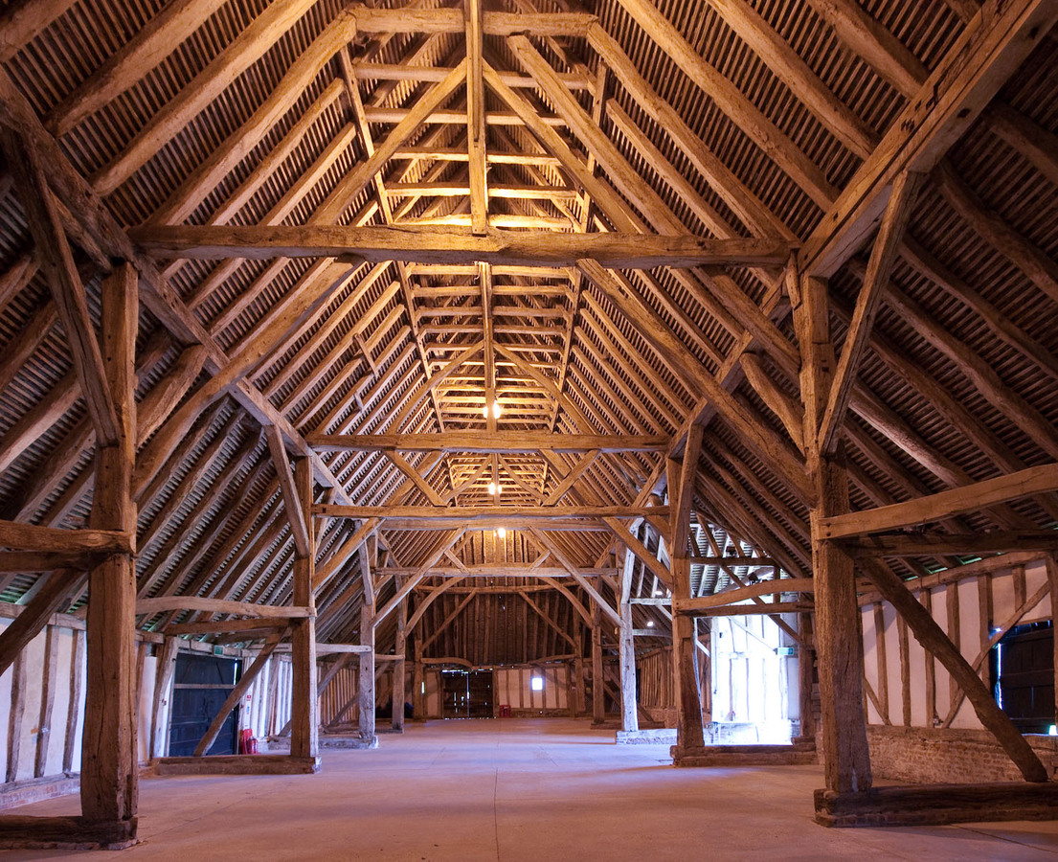

The day’s course will consider in depth three aspects of building conservation.

* The care and repair of historic timber frames and roof structures
* The range of historic roof coverings
* Problems of decay and methods of repair

The venue has been carefully chosen as it represents an extremely fine example of the medieval carpenter’s craft. The 13th century grade 1 listed Barley and Wheat barns are some of the earliest and best surviving barns in England and Europe. The associated ancillary buildings date from the 16th, 17th, and 18th centuries and illustrate the development of building techniques. The buildings illustrate a wide range of roofing and building materials used at various periods.

The day will include formal Power Point presentations, material handling sessions and first hand observations of the buildings.

Kevin Stubbs will be presenting. A regular presenter on Historic Buildings Kevin Stubbs is a Historic Buildings Consultant and comes with a background of education, archaeology and building conservation. He was Director of Archaeology for the Test Valley in Hampshire and later moved to Hampshire County Council to join the Historic Buildings Bureau, where he became the Principal Buildings Conservation Officer for the County. For eleven years he acted as the Director of a Conservation Centre and now runs his own Historic Building Consultancy and Training Company.

**Main Themes**

* The historic development of timber frames and roof structures
* Causes of decay and failure including mechanical failure, rot and insect attack.
* Approach to structural repairs, selection and use of materials and techniques.
* Thatch, problems of decay, selection of materials, fire and fire mitigation.
* Shingle, decay and repair including selection of materials.
* Tile, history, manufacture, problems of decay and repair.
* Slate, Metamorphic and stone, history and quarrying, problems of failure, selection of materials and repair.
* Lead, flashings and lead sheet, problems including under sheet corrosion, acid attack, correct detailing and installation.
* Other sheet materials and rainwater disposal.
* Chimney pots and roofscapes

Please complete the booking form or contact [alison@cpdessentials.co.uk](mailto:alison@cpdessentials.co.uk)

**Web:** [www.cpdessentials.co.uk](http://www.cpdessentials.co.uk)

CPD essentials 2016

**When:** 1 July 2016

**Where:** Cressing Temple Barns, Braintree

**Time:** 1000 - 1630

**Cost:** £120 + VAT (£144) to include refreshments, lunch and delegate notes

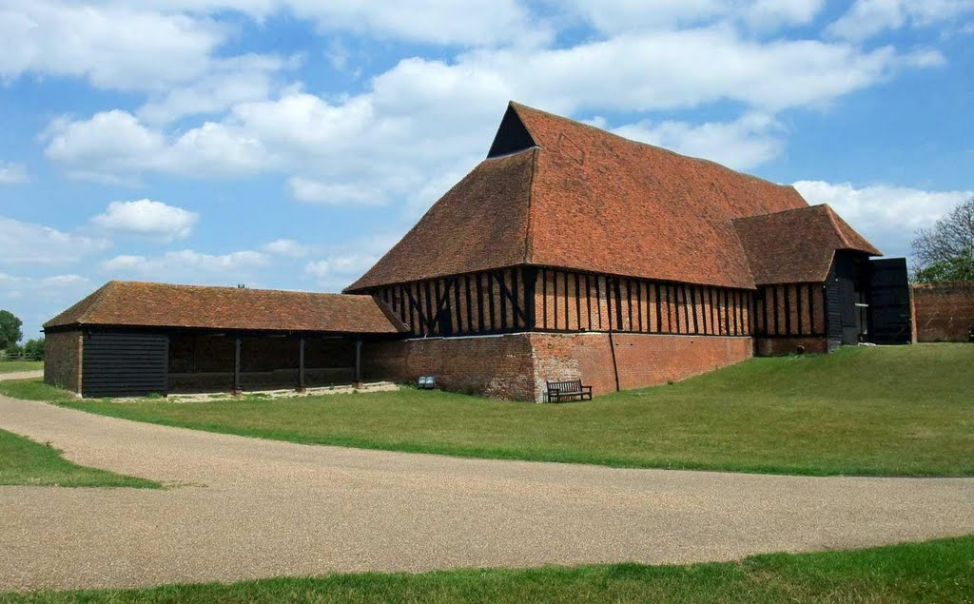

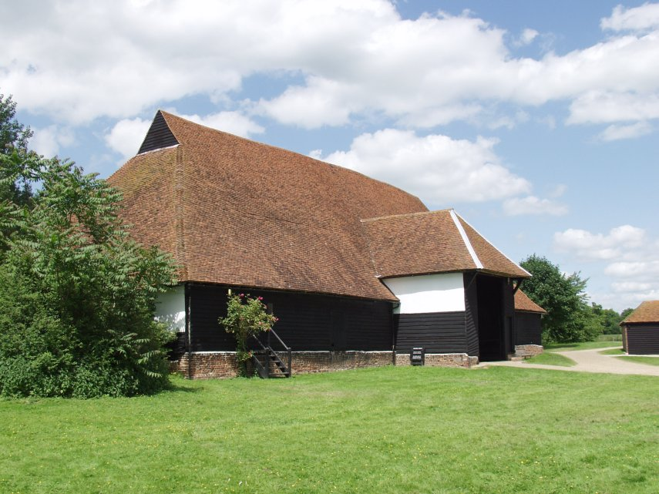

**Historic Buildings**

**CPD seminar**

**Historic roofing**

