The day’s course will consider in depth three aspects of building conservation.

* The care and repair of historic timber frames
* The care and repair of historic brickwork
* Problems of decay and methods of repair

The venue has been carefully chosen as it represents an extremely fine example of the medieval carpenter’s craft. The 13th century grade 1 listed Barley and Wheat barns are some of the earliest and best surviving barns in England and Europe. The walled garden is a good example of 16th century brickwork and the associated ancillary buildings date from the 16th, 17th, and 18th centuries and illustrate the development of building techniques. The buildings illustrate a wide range of building and roofing materials used at various periods Including timber, brick and tile. The day will include formal Power Point presentations, material handling sessions and first hand observations of the buildings.

**Main Themes**

* The historic development of timber frames and roof structures
* Causes of decay and failure including mechanical failure, rot and insect attack.
* Approach to structural repairs, selection and use of materials and techniques.
* Case Studies
* The History of Building in Brick and the Care and Repair of Brick Structures

Bricks have been a principal building material in many parts of the country since the 16th century. The history and development of brick buildings and brickmaking will be examined up to the middle of the 20th century. Looking closely at historic brickwork can give clues as to how the bricks were manufactured and laid and what alterations the building has gone through.

* Care and Repair of Historic Structures

The first important stage of this process is to identify the sources which have caused the problems of decay to occur; these must be resolved before the building can be repaired. The use of inappropriate materials can result in the rapid deterioration of historic fabric and long term structural problems. The problems of water movement, salts and frost will be discussed. Part of the day will be spent on the first hand observation of the historic buildings on site, previous repair methods used and recognising areas of potential future decay.

Please complete the booking form at [www.cpdessentials.co.uk](http://www.cpdessentials.co.uk) or contact [alison@cpdessentials.co.uk](mailto:alison@cpdessentials.co.uk)

**Historic Buildings**

**CPD seminar**

**Historic Timber Framed Structures and Brickwork**

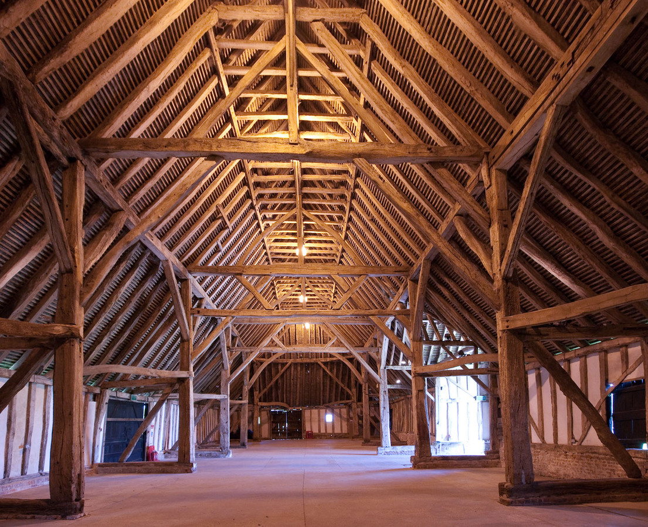

**When:** 16 June 2017

**Where:** Cressing Temple Barns, Braintree

**Time:** 1000 - 1630

**Cost:** £120 + VAT (£144) to include refreshments, lunch and delegate notes

